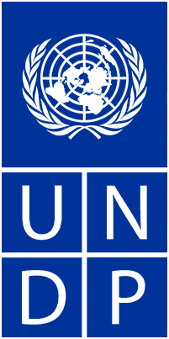

Empowered lives.
Resilient nations.

United Nations Development Programme

Mozambique

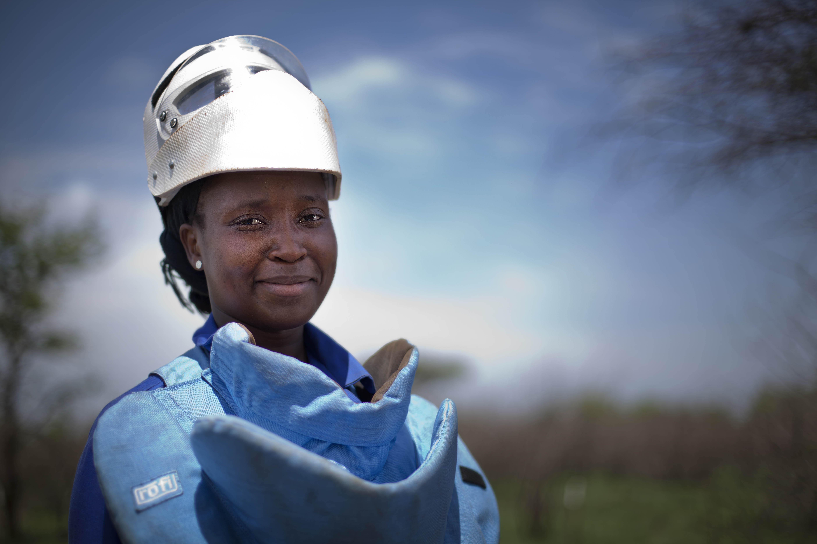
2013 – 2014 Mine Action Programme

Progress Report to
The Government of Sweden
Donor Number (231)

Table of Contents

Table of Contents 2
Acronyms 3
1.0 Executive Summary 4
2.0 The Project 6
3.0 Factors Affecting Implementation and Outputs 7
4.0 Risk Management 7
5.0 Assessment of Outputs 8
Output 1: Strengthened capacity for coordination and information management. 9
Output 2: Support to Humanitarian Demining Operations in the field. 10
Output 3: Establish a national mechanism to address residual risks from ERW 18
5.1 Gender Activities 19
6.0 Challenges, Responses and Lessons Learned 20
Annexes: 21

Acronyms
AP | Anti-Personnel
APM | Anti-Personnel Mine
APMBC | Anti-Personnel Mine Ban Convention
AVM | Anti-Vehicle Mine
CCM | Convention on Cluster Munitions
CTA | Chief Technical Advisor
GICHD | Geneva International Centre for Humanitarian Demining
GoM | Government of Mozambique
EOD | Explosive Ordnance Disposal
ERW | Explosive Remnants of War
HI | Handicap International
IMSMA | Information Management System for Mine Action
IND | National Demining Institute
IT | Information Technology
MFDE | Mine Free District Evaluation
MRE | Mine Risk Education
NMAP | National Mine Action Plan
NPA | Norwegian People’s Aid
NGO | Non-Governmental Organization
NPA | Norwegian People’s Aid
PARPA | National Action Plan for the Reduction of Absolute Poverty
PES | Government’s Economic and Social Plan (Plano Económico e Social)
SQM | Square Meters
QA | Quality Assurance
UNDP  UXO | United Nations Development Programme  Unexploded Ordnance

1.0 Executive Summary

With the generous support of the Government of Sweden, the UNDP continued to provide support during 2013 and 2014 to the Government of Mozambique in the area of mine action to meet the extension deadline for the completion of its obligations under Article 5 of Anti-Personal Mine Ban Treaty by the end of 2014. All activities were implemented according to the Annual Work Plans signed between the National Demining Institute (IND), Humanitarian Demining Operators, and UNDP.

During the reporting period, IND and UNDP regularly organized mine action stakeholder forums and other coordination meetings to monitor and exchange information on demining activities. The IND staff actively participated in international debates and discussions on demining, learning from experience of other countries and sharing Mozambique’s experience, in particular on land release and mechanical demining.

Special attention was paid to the information management database as one of IND’s key roles is to maintain the records of the national landmine problems and the progress made in addressing the threat, as well as accurately quantifying the remaining problem. IND is also responsible for informing national and international stakeholders regarding the extent of the landmine problem and progress made on clearing all known mined areas. The IND Database Unit continued to require improvement, and in this regard, training courses were organized in partnership with GICHD during 2013 and 2014. Necessary equipment and technical assistance was provided to IND to enable the much-improved analysis of demining information in the country.

Mine clearance activities were conducted with the financial support of Sweden by four humanitarian operators in accordance with the distribution of tasks agreed with IND. Annual Work Plans were signed with APOPO, Handicap International, Halo Trust and Norwegian People’s Aid with funding assigned as per the UNDP project proposal. Considering the current mine situation in the country and the distribution of humanitarian operators on the ground, funding allocations by IND and UNDP were based on the level of contamination, government priorities for economic and social development, and the existing funding gaps of the operators themselves. The mine clearance activities by the four demining operators were conducted and completed as planned in the provinces of Inhambane, Manica, Sofala and Tete.

In total, the humanitarian mine action activities financially supported by the Government of Sweden contributed to the clearance and release of 93 suspected or confirmed hazard areas covering a total of 6,496,965 square meters, including 266 electrical pylons along the Beira I and Beira II power lines, and the destruction of 21,918 anti-personnel landmines, 4 anti-vehicle mines and 396 items of unexploded ordnance.

The mine action quality management system continued to be used by IND Quality Assurance team. The IND QA team undertook 508 monitoring missions of the demining operations of the UNDP funded mine action operators. These visits covered the provinces of Inhambane, Maputo, Manica, Sofala and Tete. During the visits, the progress of demining operations under way were evaluated, as well as the ability of operators’ capacity in terms of personnel, equipment, degree of compliance with the Mozambican National Mine Action Standards. This involves: command and control system, marking, manual demining, mechanical demining, animal mine detectors and emergency medical response. The IND QA Team also conducts post-demining assessments to confirm conclusion of demining tasks as part of the government’s Mine-Free District Evaluations.

As a result of the humanitarian mine action and quality assurance activities supported by the government of Sweden, Mozambique made good progress during the reporting period. This is evident in the number of mine-free districts that increased from the start of 2013 from 105 districts to 124 districts at the end of 2014 out of a total of 128 districts in Mozambique. While Mozambique fell short of its goal of classifying all 128 Districts as free of all known mined areas by the end of 2014, IND continues to work and hopes to classify the remaining 4 districts in Sofala and Manica as mine free in 2015.

Despite the tremendous progress achieved during the project period, Mozambique still faced several challenges to complete demining by the deadline established by the Anti-Personnel Mine Ban Convention. As part of the regular evaluation of mine action progress, the National Demining Institute and the Government of Mozambique determined that Mozambique needed an additional 10-months to complete their obligations to clear all known mined areas in accordance with Article 5 of the Mine Ban Convention. In 2013, the Government of Mozambique therefore submitted and was granted a request to extend the Mozambique’s deadline to comply with article 5 of the Mine Ban Convention until December 2014. Thanks to the support of a number of partners, Mozambique came extremely close to completing implementation by its 31 December 2014 deadline. Despite the best efforts of the National Mine Action Programme, Mozambique was unfortunately unable to complete the demining of all known mined areas by the December 2014 Deadlines. As of 28 January 2015, a total of 56 tasks covering 289,660 square meters remain to be surveyed and cleared in the Provinces of Manica, Sofala and Inhambane. Having missed the December 2014 deadline, Mozambique is committed to being highly transparent with regard to the challenges that remain and Mozambique’s plan to overcome them as soon as possible. All remaining demining tasks are well known and the National Demining Institute has developed a plan with the Humanitarian Demining Operators to complete them as soon as possible and declare the remaining districts as free of all known mined areas within 2015.

The third objective of the project, the establishment of a national mechanism to address residual risks from unexploded ordnance (UXO) and other explosive remnants of war, was not realized within the original timeframe of the project. The GoM’s extension of the demining deadline until December 2014 led to the postponement of the training and equipping for police in Explosive Ordnance Disposal (EOD) in mine-free provinces. In 2014, IND and UNDP partnered with the GICHD to produce a capacity assessment of Mozambique’s National Capacities to Manage Residual Contamination from Explosive Remnants of War after the end of demining. This partnership reduced the cost of expenditures for these activities. The capacity assessment was completed in 2014 and used by UNDP, IND and GICHD to draft a proposed strategy for Mozambique to manage the residual contamination from explosive remnants of war. IND intends to use the capacity assessment and draft strategy in 2015 to advise the government on a transition to a national mechanism to manage residual contamination after the completion of demining and the establishment of a training centre in Mozambique to manage residual contamination.

The project had a real impact on the ground, by establishing new national capacities for mine action and the management of the residual risks from Explosive Remnants of War (ERW). But most importantly the project has benefitted the local population in mine affected areas through the clearance and release of previously mine suspected areas back to local communities for their future use. While the project was not able to ensure the completion and release of all known mined areas within the project period, the Government of Mozambique and UNDP are confident the remaining work can be completed within 2015 provided sufficient support is available. The IND and the UNDP estimate that sufficient financial resources exist to complete the remaining work in 2015 should Mozambique receive no-cost extensions from existing donors. In this regard, the UNDP Mine Action Project kindly requests a no-cost extension from the Government of Sweden to utilize the remaining balance of unspent funds from the Swedish contribution to support mine clearance activities in 2015 and training of the police for management of residual contamination from ERW.

2.0 The Project

In 1997, Mozambique joined the Anti-Personnel Mine Ban Convention (APMBC). As a result, in 1999, the Government of Mozambique (GoM) created the National Demining Institute (IND) to coordinate all activities related to mine action. Mine action has also been included in the Government’s PARPA II (Mozambique’s Poverty Reduction Strategy Paper) as a cross-cutting issue, emphasising the important connection between addressing the impact of mine contamination and the promotion of sustainable development. Under Article 5 of the APMBC, Mozambique committed to clear all known mined areas in its territory or control by March 2009. However, a review of the remaining landmine threat in 2008 indicated that around 12 million square meters of land, across a total of 541 sites, and 220 km of roads still required clearance. In addition, some infrastructure sites and border tasks remained, these needed to be surveyed to better define the suspected hazard areas. In this regard, in October 2008, Mozambique requested and received a five year extension of the deadline for its APMBC Article 5 obligations to March 2014.

In April 2008, the GoM adopted a new National Mine Action Plan (NMAP) to address the remainder of the problem during the next five years. To facilitate the cost-effective and efficient prioritization of remaining areas, the government adopted a district-by-district approach to identify all known mined areas and eliminate any suspicion of AP mines. Under this Mine-Free District approach, each distinct area of operations sees all tasks completed, before demining teams move to other districts or provinces. It therefore ensures that all reasonable effort is exerted to identify all mined areas and remove the negative impact of AP mines in communities thus fulfilling the GoM’s obligations under Article 5. It should be noted, however, that even when the AP mine threat has been addressed, an incalculable number of other Explosive Remnants of War (ERW) will remain in Mozambique, posing daily threats. Addressing problems associated with ERW will continue to be a key challenge for the government in years to come and will require the development of a longer-term policy to mainstream clearance work into existing civil protection systems and budgets.

To support the implementation of the NMAP, the GoM and the UNDP are implementing the project, “Support to the National Demining Programme 2012-2015” (UNDP Project no. 00080471) in line with the goals of the project document agreed upon in 2012 and reviewed each year. The overall objective of this project is to support the government and build national capacities to respond to the challenges that landmine contamination and ERW continue to pose to human security and development in Mozambique.

In December 2012, the Government of Sweden agreed to provide support to the above UNDP project in Mozambique, “Support to the National Demining Programme” as outlined in the project documents and contribution agreements signed by the Embassy of Sweden and the UNDP Country Office in Mozambique.

While great progress was achieved during the five-year extension period, the identification of previously unknown mined areas prevented Mozambique from completing the demining of all mined areas before the extended deadline of 1 March 2014. In May 2013, the Government of Mozambique submitted a request to extend the demining deadline under the Mine Ban Convention by ten months. The second extension period allowed deminers to concentrate on the conclusion of all demining tasks remaining along the Mozambican-Zimbabwean border and the remaining suspected hazard areas in the central region of the country (i.e. Inhambane, Manica, Sofala and Tete Provinces). Mozambique’s extension request was formally approved in December 2014 by the 13th Meeting of State Parties to the Mine Ban Convention, which established the new treaty deadline to clear all known mined areas in Mozambique as 31 December 2014. Due to the continuation of demining operations in 2014 under the extension period, the UNDP project likewise submitted a request to the Embassy of Sweden in November 2014 for additional funding and an extension to the existing project. Within the 2014 extension period, the UNDP project aimed to support the achievement of the Government’s goal of clearing all known mined areas and establishing a national capacity for the management of residual ERW. The extension request for the project was granted by the Government of Sweden in December 2014 with the additional funds received this same month.

3.0 Factors Affecting Implementation and Outputs

- Partnerships – Due to its own characteristics, mine action projects require partnerships with multiple multilateral partners, government institutions including the Ministry of Interior, the Ministry of Defence, and the National Demining Institute, as well as private companies and various NGOs. Some of these partnerships were more effective than others. Unfortunately, the slow pace of mine clearance by the engineering unit of the Mozambican Armed Defense Forces at a former munitions depot near Maxixe in Inhambane Province was problematic. This required the additional support from the humanitarian demining operator Handicap International to ensure that the areas FADM was tasked to clear were completed within the deadline established by the GoM. An additional challenge is the lack of clarity on responsibilities between Ministries of Defense and Interior to define which of these institutions will deal with the residual threat posed by ERW long after the completion of demining in Mozambique.

- External Environment – While the mine action component of the project benefitted from the government’s continued attention and willingness to prioritize mine action, the GoM’s financial contribution has been decreasing due to the problems related to the exchange rates losses. Delays caused by periodic flooding and temporary insecurity in some areas of operations also prevented the humanitarian demining teams from safely accessing suspected mined areas. Military clashes in the central region of Mozambique in 2013 and 2014 prevented demining teams from safely accessing the mine suspected areas causing delays to the scheduled completion of districts and provinces, particularly in the provinces of Inhambane, Sofala and Manica, in accordance with the National Mine Action Plan.

- Discovery of previously unidentified mined areas – Although good progress was achieved in clearing the areas identified in the 2007/2008 Baseline Assessment, a total of 512 new suspected hazard areas corresponding to approximately 22.2 million square meters were identified as a result of the new surveys and the district-by-district approach implemented between 2008 to 2011. To address these newly identified hazard areas that were not captured in the 2007/2008 Baseline Assessment, the mine action community has had to increase the demining capacity in the country in order to stay on track to complete demining by 2014.

4.0 Risk Management

The main risks to the mine action component were:
- Government and UNDP commitment to address the issue of mine action funding.

The 2012 and 2013 mine action registered an increase in funding from some donor partners, from a low point in funding from 2008 to 2010. This increase in funding positively impacted mine action activities in Mozambique and was a result of well-coordinated resource mobilization efforts led by the IND and UNDP. However, Mozambique needed to close the remaining funding gaps for mine action activities and ensure that the funding was allocated as quickly as possible when the demining teams needed it the most. The UNDP and IND therefore continued to coordinate resource mobilization efforts while looking at several approaches to reduce costs for demining operations. Through targeted and effective allocation of funds and tasking by the UNDP and IND respectively, the project continued to increase the number of demining tasks completed and annual square meters released. The utilization of mechanical demining assets and land release methodology also ensured that the GoM continued to make progress towards its 2014 goal.

- Limited and restricted access to some mine suspected areas.

At times, the demining teams were not able to safely access all known mine suspected areas in order to complete their assigned tasks in accordance with the NMAP. The lack of access to some areas was primarily caused by two external factors. First, heavy rains during the monsoon season from December to March each year regularly cause flooding that prevents demining teams from reaching their assigned areas and completing their assigned tasks. This issue depends on the severity of the rainy season and is usually isolated to certain areas of the country. The IND and humanitarian demining operators take this periodic flooding into account when planning demining operations and encourage teams to be flexible and work during the rainy season in whichever areas can be safely accessed. The second external factor that prevents access to mine suspected areas was the political tensions and military standoffs between the ruling government and the primary opposition party. Temporary insecurity and political tensions in Sofala province that started in 2012 and continued until August 2014 led to the suspension of some demining tasks, delaying completion of the assigned tasks. The IND regularly coordinates information on the security situation and encourages humanitarian operators to work in those areas that they can safely access. The GoM also tried everything it could to ensure a safe and secure environment that would allow for the completion of all demining tasks in accordance with Mozambique’s mine action obligations under the APMBC.

5.0 Assessment of Outputs
In accordance with the project document agreed between the UNDP and the GoM, the Government of Sweden’s financial assistance to the Mine Action Programme contributed to the delivery of three overall project outputs:
- Strengthened capacity of the IND in coordination and information management.
- Support provided to humanitarian demining operators in the field, including post-clearance inspections and official handover of released land to the provincial authority utilizing the mine-free district approach.
- Establishment of a national mechanism to address residual risks from UXO as part of the government approach to ERW.

The first output mentioned above was fully achieved through the implementation of agreed project activities outlined in Annual Work Plans, however with some funds remaining unspent. The second and third outputs were partially achieved through the implementation of agreed project activities outlined in the Annual Work Plans and delivered by implementing partners. Not all key activities under Output 2 could be achieved within the duration of the project due to delays and challenges faced by the humanitarian demining operators in the field in 2013 and 2014. The main challenges faced by the demining operators reported in 2013 and 2014 were:
- Military hostilities creating a situation of temporary insecurity persisted between January and August 2014 in the provinces of Manica and Sofala. This prevented access to some mined areas in these provinces and created transportation and logistical difficulties to access the demining tasks.
- Higher transport and logistical costs were incurred due to the continuing insecurity and productivity in the affected areas was reduced. For example, due to conflict in Southern Sofala, teams and equipment from the south had to travel an alternative route via Zimbabwe which delayed deployment and increased costs.
- Limited availability of mechanical demining assets in the provinces of Manica and Sofala in 2013 resulted in slow progress on a number of demining tasks in the Districts of Cheringoma, Dondo, Gondola and Nhamatanda, some of which were delayed until 2014 when additional mechanical demining assets became available.
- Heavy rains and flooding from January to March 2013, delayed the start of demining operations for that year in Manica, Inhambane and Sofala.
- Heavy rains in December 2014, led to the suspension of some demining tasks in Manica and Sofala Provinces that otherwise would have been completed by the 31 December 2014 deadline.

Output 3 of the project was only partially achieved during the 2013-2014 project cycle because many of the planned activities that would deliver the expected output were delayed until 2014 and 2015 once it became clear that demining activities under Output 2 would not be completed within the 2014 deadline. The GoM’s extension of the demining deadline until December 2014 led to the postponement of the training and equipping for police in Explosive Ordnance Disposal (EOD) in mine-free provinces.

The summary below contains an assessment of progress towards the achievement of the individual project outputs during the reporting period and highlights the results of the financial assistance to the project from the government of Sweden.

Output 1: Strengthened capacity of the National Demining Institute in coordination and information management.

As outlined in the project document, Swedish funding was used to strengthen project management and the capacity of the IND to coordinate mine action assistance. This included strengthening information management for the purpose of reporting and sharing of information with all partners.

The results and status of the activities under this output are summarized in the table below:

Results Summary Table for Output 1
Project Output and Activity | Planned Activity and Indicator | Results | Remarks
Output 1: Project Management and Strengthening the capacity of the National Demining Institute | Project Activity 1.1 - UNDP  Support to UNDP Monitoring and Evaluation of programme activities including regular site visits, audits, evaluation and donor reporting. | During 2013 and 2014, UNDP Technical Advisor conducted 14 site visits to demining operators, UNDP conducted 5 risk assessments and 5 audits of implementing partners. UNDP Recruitment of a Senior Accountant to assist the demining project was delayed until 7 October 2013 when the accountant entered on duty. The accountant’s contract ended 5 months earlier than expected in August 2014, due to unforeseen reasons. As a result, financial expenditure under this activity was lower than expected because the accountant was only on contract for 10 months as opposed to the initial planned 15 months. | Fully achieved with delays
 | Project Activity 1.4 – IND  Strengthen the management of information system to make it consistent; gather and systematically monitor data to be shared with all partners and the media. | Funding was utilized to purchase new and disposable equipment for the database in IND, training for IND database technicians and support from the NPA technical advisor for Information Management. In 2013 and 2014, 115 maps and reports were produced by the IND database team with sex and age disaggregated data (50 in 2013 and 65 in 2014).Due to parallel funding from other partners, funding in this activity was underspent. UNDP requests a no-cost extension to utilize the remaining positive balance for demining in 2015. | Fully achieved with under expenditure; Request balance used for demining in 2015

Output 2: Support to Humanitarian Demining Operations in the field.
Under the authority of the Ministry of Foreign Affairs and Cooperation, the IND accredits and issues licences to demining operators to carry out operations in Mozambique. During the project period, the Government has accredited four international humanitarian operators, namely, APOPO the HALO Trust, Handicap International and Norwegian People’s Aid (NPA) to carry out mine clearance operations in support of clearing all known areas suspected or confirmed to contain anti-personnel mines by the end of 2014. The IND is responsible for prioritising and allocating tasks for mine clearance. During the reporting period, the financial support of the Government of Sweden was assigned by IND and UNDP to support the following demining operations:

- Halo Trust: Province of Tete
- Handicap International: Provinces of Inhambane, Manica and Sofala
- APOPO: Provinces of Manica and Sofala
- Norwegian People’s Aid: Provinces of Manica and Tete
- IND QA Teams: Provinces of Maputo, Inhambane, Manica, Sofala and Tete

All activities supported by UNDP were implemented in accordance with the Annual Work Plans agreed upon by the demining operators, the IND and UNDP.

The results and status of the activities under this output are summarized in the table below:

Results Summary Table for Output 2
Project Output and Activity | Planned Activity and Indicator | Results | Remarks
Output 2: Support to humanitarian demining operations in the field | Project Activity 2.1 – APOPO  Survey, clearance and release of approximately 1,258,600 square meters of mine suspected area in the Cheringoma District of Sofala Province.  APOPO demining teams to clear and release 208,500 square meters of the Nhamucuarara Border Minefield in Manica District.  Survey and clear at least 34 towers along the Beira I and Beira II Powerlines in Nhamatanda District in Sofala and Gondola District of Manica. | In 2013, APOPO completed surveys of all remaining mined areas in Cheringoma identifying a total of 21 remaining demining tasks and 2 Explosive Ordinance Disposal tasks. By October 2013, Apopo had released and cleared a total of 15 tasks. But, in October2013, operations in Cheringoma were suspended due to insecurity in the region, leaving 8 tasks uncompleted. In 2014, the security situation in Cheringoma improved allowing APOPO to resume operations and complete all remaining tasks by November 2014. In total, APOPO operations in Cheringoma District resulted in the release through survey and clearance of a total of 2.1 million square meters of previously mine suspected area and the destruction of 11 items of unexploded ordnance and 239 items of small arms ammunitions.  In 2014, APOPO teams began technical survey and clearance of the Nhamucuarara border Minefield and cleared a total of 41,498 sq meters of land determined to be inside Mozambican territory resulting in the destruction of 19 anti-personnel mines. The remaining 167,002 sq meters was determined to be located inside Zimbabwean territory and was therefore cancelled from the Mozambican task list.  In 2014, APOPO teams continued work on mine suspected pylons along the Beira I and Beira II Powerlines in Gondola and Nhamatanda district. In Gondola District, APOPO teams cleared and released a total of 39 pylons releasing a total of 199,181 sqm of previously suspected mined areas resulting in destruction of 2 anti-personnel mines and 2 UXO. In Nhamatanda District, APOPO teams cleared and released a total of 13 pylons releasing a total of 74,989 sqm of previously suspected mined areas resulting in destruction of 5 anti-personnel mines and 6 items of small arms ammunition. | Fully achieved in 2014; but with delays due to security situation.
 | Project Activity 2.1 – Halo Trust  Manual Clearance of 271,000 square meters of confirmed mined areas along the Chinzunga section of the Cahora Bassa Dam mine belt in Cahora Bassa District of Tete.  Mechanical Clearance of 9,600 square meters of confirmed mined area along the Nhanchenje section of the Cahora Bassa Dam mine belt in Cahora Bassa District of Tete Province.  Manual Clearance of 287,955 square meters of confirmed hazard area in the N’Soluwamuthu border minefield in Cahora Bassa District of Tete Province  Manual Clearance of 18,990 square meters of Mine Suspected area in Changara District of Tete Province | Clearance in Chinzunga in 2013 was delayed due to the rains in January washing out the road. The road was repaired in May 2013 and HT teams deployed in June. HT increased its presence to 11 manual teams as a result of Swedish funding. Following the 2014 rainy session that also limited access to the minefield, HT eventually completed the Chinzunga minefield in May 2014. In total, Halo Trust cleared, 113,739 sqm of the minebelt resulting in the destruction of 2068 anti-personnel mines in 2013 and 2014. HT reports that Swedish funded teams specifically cleared 16,771sqm and destroyed 335 AP mines in Chinzunga.  In 2013, HT concluded all manual clearance in Nhanchenje and concentrated at the end of 2013 and start of 2014 on mechanical demining on the Nhanchanje section of the minebelt where mines were found at a deeper depth than normal (60 cm on average). The area was completed in April 2014 resulting in the excavation and clearance of 9,600 square meters and the destruction of more than 672 anti-personnel mines. HT reported that the Swedish funded teams specifically cleared 5,012 sqm and destroyed 503 APM.  Between 2012 and 2014, HT cleared the longest known stretch Rhodesian Border Minefield that existed on Mozambican territory located at N’Soluwamuthu in Tete Province. The minefield was completed by HT in November 2014. In 2013 and 2014 HT cleared a total of 315,371 square meters of this dense border minefield, resulting in the destruction of 15,019 anti-personnel mines. HT reports that Swedish funded teams specifically cleared 19,895sqm and destroyed 1,148 AP mines.  Due to the availability of extra APOPO teams in Tete Province, the IND allocated two of the three remaining tasks in Changara District to APOPO, while HT completed the third remaining hazard area resulting in the release of 3,970 square meters of previously mine suspected area. | Fully achieved in 2014; delays due to rainy season and difficult terrain.
 | Project Activity 2.1 – Handicap International  Complete clearance of 1 confirmed hazard area of ca. 40,000 square meters around an old military arms depot in Maxixe District of Inhambane Province.  In 2013, complete clearance around 160 electric towers totaling 400,000 square meters of mine suspected area in Nhamantanda District of Sofala Province. In 2014, clear at least 100 Towers along the Beira I and Beira II Powerlines in Nhamatanda District in Sofala.  Complete clearance of 5 suspected hazard areas in approximate area of 11,000 square meters in Nhamantanda District of Sofala Province  In 2013, Complete Clearance of 5 suspected areas totaling approximately 54,000 square meters in Mussorize District of Manica Province. In 2014, survey and clear the 16 remaining mine suspected areas in the District of Mossurize in Manica Province resulting in the release of at least 552,333m sq meters ensuring completion of all known minefields in this district by 2014  Complete Clearance of 60 Suspected Hazard Areas totaling 1,800,000 square meters in Chibabava District of Sofala Province  Complete Clearance of 32 suspected mine areas totaling 333,771 square meters in Inhassoro District of Inhambane Province. | In 2013, HI in partnership with the Army cleared a total of 58,263 square meters of confirmed hazard area of a defensive mine belt around the Maxixe ammunition depot resulting in the destruction 48 AP mines, 10 UXO and 2,350 items of Small Arms Ammunition. In 2014, an additional 64,716 sqm of hazardous areas identified within the depot were cleared resulting in the destruction of another 8 UXO, 1 AP mine and 2,974 items of small arms ammunition.  Due to flooding along the powerline in the rainy season and insecurity in the province, the completion of the powerline was delayed and included in the Government of Mozambique’s extension request under the Mine Ban Treaty to complete by December 2014. In 2013, HI completed 58 electrical towers resulting in the release through survey and clearance of 158,553 square meters and the destruction of 1318 anti-personnel landmines and 1 UXO. In 2014, HI completed another 156 towers resulting in the release through survey and clearance of 297,332 square meters and the destruction of 2091 anti-personnel landmines and 8 UXO. HI was not able to compelte all towers by December 2014. The remaining 25 towers along the Beira I and Beira II powerlines were reassigned to Halo Trust and APOPO for clearance in 2015.  In 2013, HI cleared 4 of the 5 suspected hazard areas resulting in the release of 12,638 square meters of previously mine suspected area, resulting in the destruction of 2 UXO and 4 items of small arms ammunition. Clearance of the last remaining area of ca. 3000 sqm was not completed in 2014 and was assigned to NPA for completion in 2015.  In 2013, the demining tasks in Mussorize were not started as HI teams were occupied on other tasks. In 2014, HI teams started clearing the tasks in Mossurize District, fully completing 4 tasks and partially completing a fifth by the end of the year. In total, HI teams cleared 190,584 sqm resulting in the destruction of 25 AP mines, 2 UXO and 439 items of small arms ammunition. Unfortunately, due to weather delays and transport difficulties caused by the insecurity in Sofala Province, HI was not able to finish all assigned tasks in Mossurize by the end of 2014. At the end of 2014, other tasks were assigned to Halo Trust, who expects to complete all remaining tasks in Mossurize District in 2015.  In 2013 and 2014, HI surveyed and cleared a total of 15 Suspected Hazard Areas in Chibabava resulting in the release of 1,775,898 sqm and the destruction of 129 anti-personnel mines, 347 UXO and 2,693 items of small arms ammunition. At the end of Oct 2013, demining in Chibabava was suspended due to insecurity in the district. Demining continued in 2014 once the security situation allowed operations to restart. Due to the delays, several tasks in Chibabava District were reassigned in 2014 to available APOPO and NPA teams. APOPO and NPA will complete work in Chibabava District in 2015.  In 2013, HI teams cleared and released a total of 32 suspected mined areas in Inhassoro resulting in the release of more than 733,753 square meters and the destruction of 9 AP mines and 5 UXO and 17 items of small arms ammunition. In 2014, HI cleared another 5 suspected hazard areas reported by local communities resulting in the clearance of another 21,552 square meters of previously suspected mined area, however no further munitions were found in the additional 5 areas. As a result of HI’s work in Inhassoro District, the Government declared the district as ‘mine-free’ in 2014. | Partially achieved; activities continuing
 | Project Activity 2.1 – NPA  Complete Mine Free District Evaluations in the Districts of Chifunde, Mutarara and Cahora Bassa in Tete Province.  Survey, Clearance and Release of 438,400 Square meters of mine suspected areas in the districts of Manica and Sussendenga in Manica Province. Survey and clear at least 119,400 square meters of mine suspected areas in the Mucudo border minefield in the district of Manica in Manica Province ensuring completion of the minefield by 2014. | During 2013, NPA has completed the Mine Free District Evaluations of Chifunde, Mutarara and Cahora Bassa. The Government has now classified Mutarara and Chifunde Districts as ‘mine-free’. Cahora Bassa was declared ‘mine-free’ in 2014 once demining operations along the Cahora Bassa Dam were completed.  In 2013, NPA completed demining of one confirmed hazard area in Sussendenga district resulting in the release of 7302 square meters and the destruction of 4 anti-tank mines. In Manica District, NPA completed clearance of 42,834 sqm of the Chiwijo Border mine field destroying a total of 676 anti-personnel landmines. During the clearance of the Chiwijo minefield, NPA found border beacons within the minefield. The remaining part of the minefield was canceled from the Mozambican demining task list, once it was determined the remaining section was inside Zimbabwe. In 2014, NPA worked on the border minefields at Mucodo and Mudododo in Manica District clearing a total of 108,190 sqm in both minefields and destroying 36 AP mines in the Mudododo minefield. Another 136,610 sqm with the majority of the mine contamination were determined to be in the territory of Zimbabwe and therefore were cancelled from the Mozambican demining task list. | Fully achieved
 | Project Activity 2.2 - IND  Support Quality Assurance (QA) Teams of the National Demining Institute to monitor and inspect demining activities to guarantee the quality and security of the work done and disseminate Mine Risk Education (MRE) materials to raise awareness in communities about the danger of landmines and UXOs. | In 2013, the IND QA team conducted a total of 215 inspections of ongoing demining operations in the following provinces: 70 in Maputo, 49 in Inhambane, 41 in Sofala, 36 in Manica and 19 in Tete. QA teams also delivered a total of 30 MRE sessions to a total audience of 985 men, 813 women, boys and girls in the following provinces: 7 in Maputo, 3 in Inhambane, 5 in Manica, 12 in Sofala and 3 in Tete. In 2014, the IND QA team conducted a total of 293 inspections of ongoing demining operations in the following provinces: 68 in Maputo, 103 in Inhambane, 67 in Sofala, 33 in Manica and 22 in Tete. QA teams also delivered a total of 81 MRE sessions in 2014 to a total audience of 8159 men and boys, 6740 women and girls in the following provinces: 18 in Inhambane, 11 in Manica, 46 in Sofala and 6 in Tete. | Partially achieved; activities continuing in 2015
 | Project Activity 2.3 – IND  Support the National Demining Institute and provincial demining committees to classify districts as mine free through assessment and handover to communities in the freed areas. | In 2013, another 6 districts were declared mine free, thus increasing the total number of Mine Free Districts in Mozambique to 111. In 2014, another 13 districts were declared mine free, bringing the total number of Mine Free Districts to 124 out of 128. While Mozambique fell short of its goal of classifying all 128 Districts as free of all known mined areas by the end of 2014, IND continues to work and hopes to classify the remaining 4 districts in Sofala and Manica as mine free in 2015. | Partially achieved; activities continuing
 | Project Activity 2.4 – IND  Enhance mechanical demining capacity in Mozambique by acquiring a demining machine to clear old roads in the Provinces of Sofala and Manica that are suspected to contain anti-vehicle landmines. | IND concluded procurement of Minewolf MW240 machine in Q1/2013. The MW240 Demining Machine arrived in Sofala Province in Q2/2013 and was deployed to Cheringoma in June. A training of mechanics and operators was conducted in July to August 2013 and resulted in the certification of 10 Mozambican technicians from IND and the Humanitarian Demining Operators. The IND’s procurement process resulted in the selection of the MW240 at a price lower than initially expected for a machine that met all specifications. This resulted in savings to the project and a balance of more than $300,000 USD, which IND requests to use for further support to mechanical demining. In 2014 the funding was not used to purchase a transport truck for the demining machine and mobile workshop. Instead the funding was used for the purchase of spare parts and consumable items as well as an additional mechanical training for 7 demining technicians from IND, HI and APOPO that was held in Cheringoma District in September 2014. | Fully Achieved with under expenditure; Request balance used for demining in 2015.

Examples of Photos from the Field:
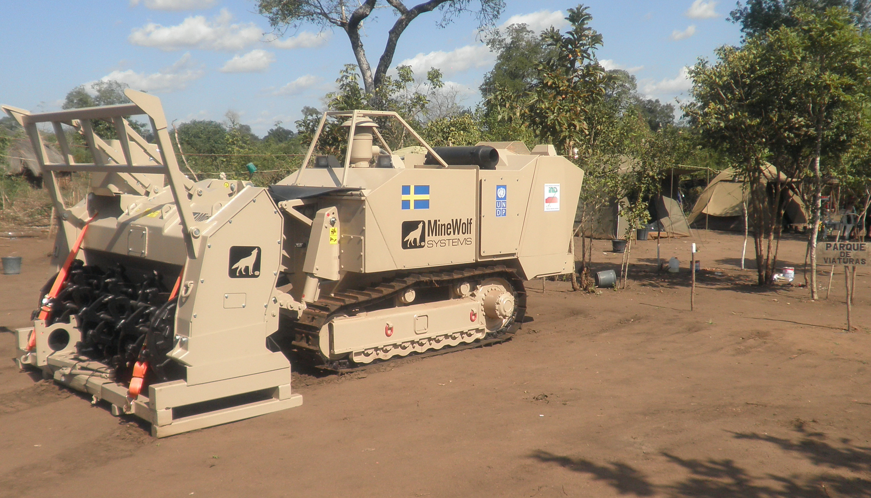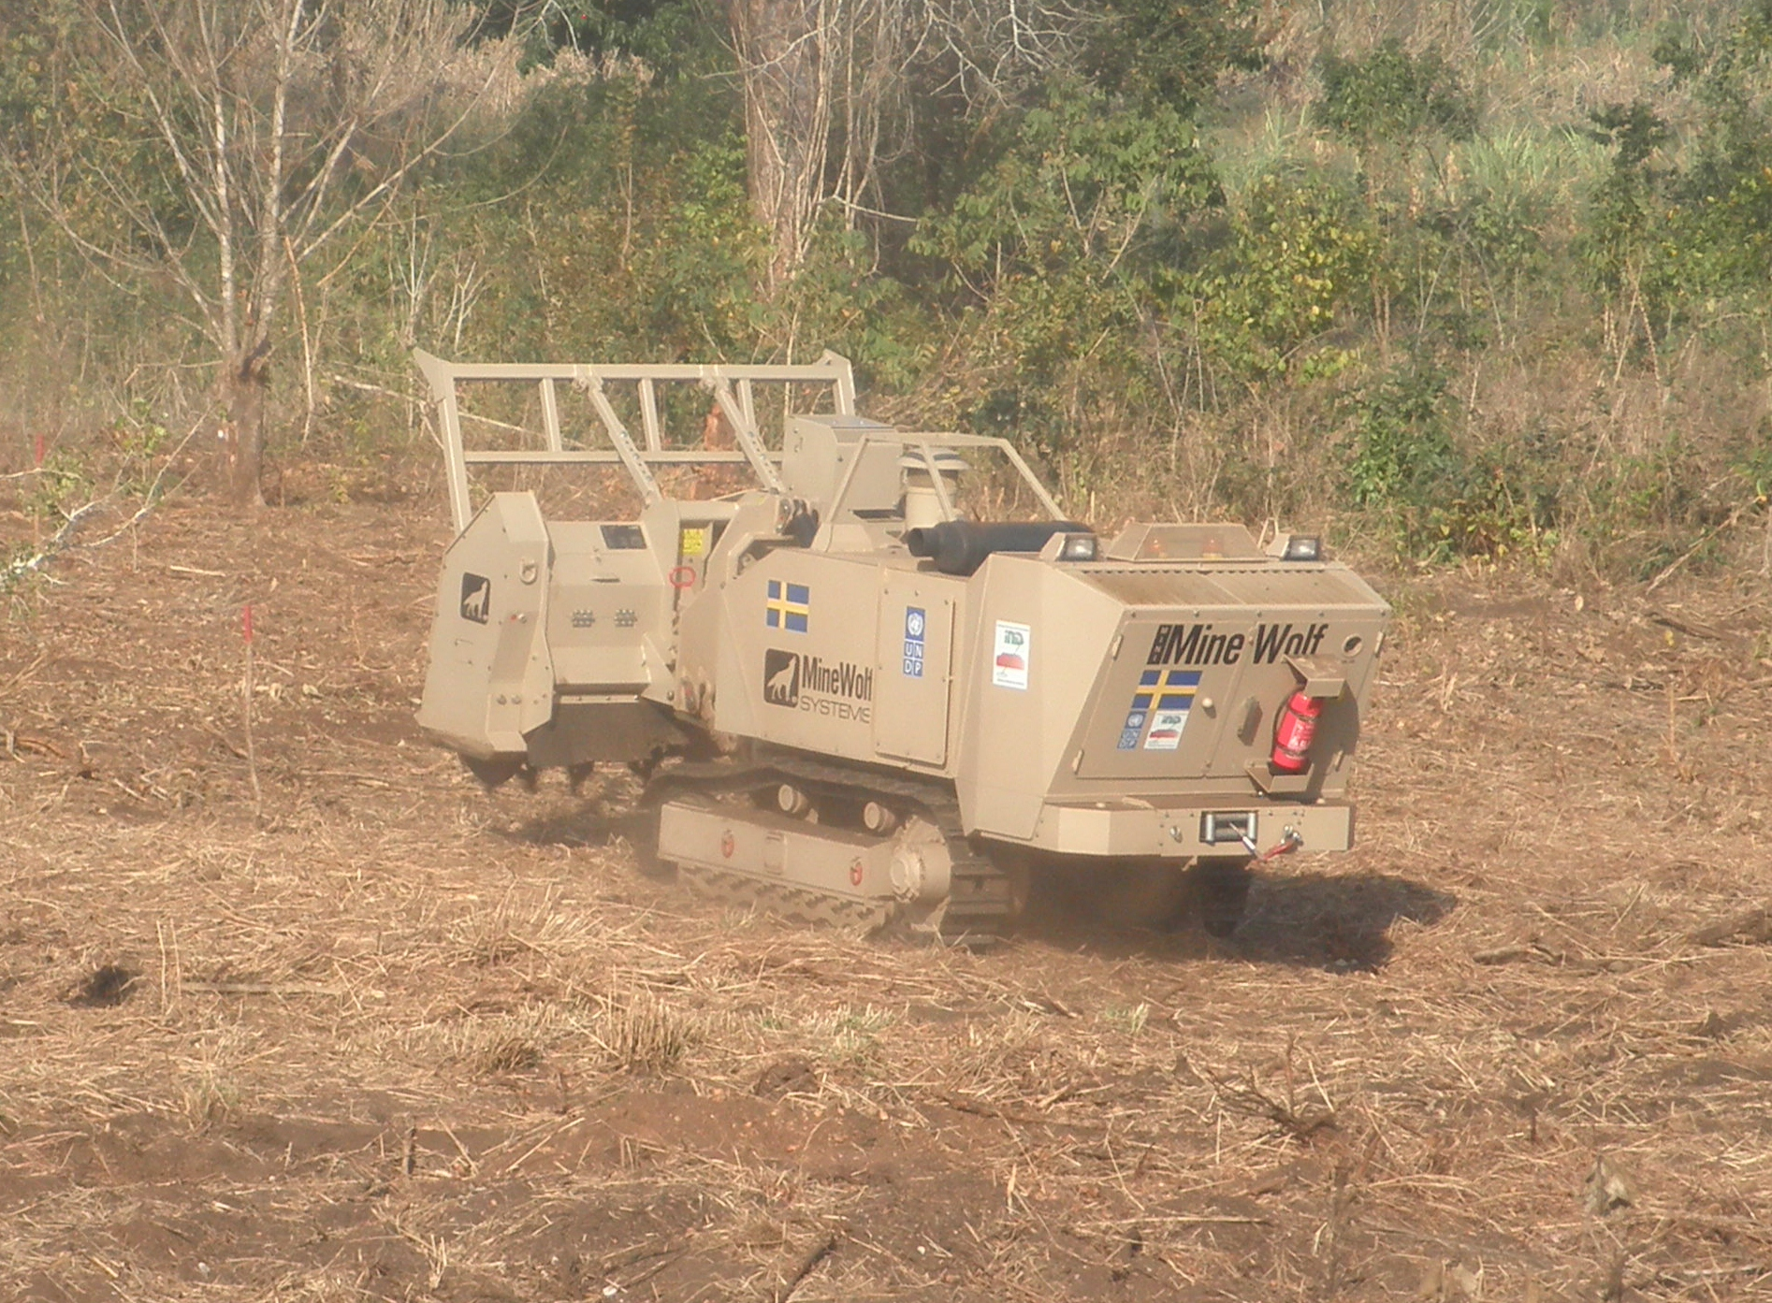
Photos 1 and 2: The Mine Wolf 240 demining machine arrives in Caia, Sofala Province, in July 2013 to begin its first deployment in Mozambique. Capable of processing 12,000 sq. meters a day, the machine greatly accelerates demining operations in the field.

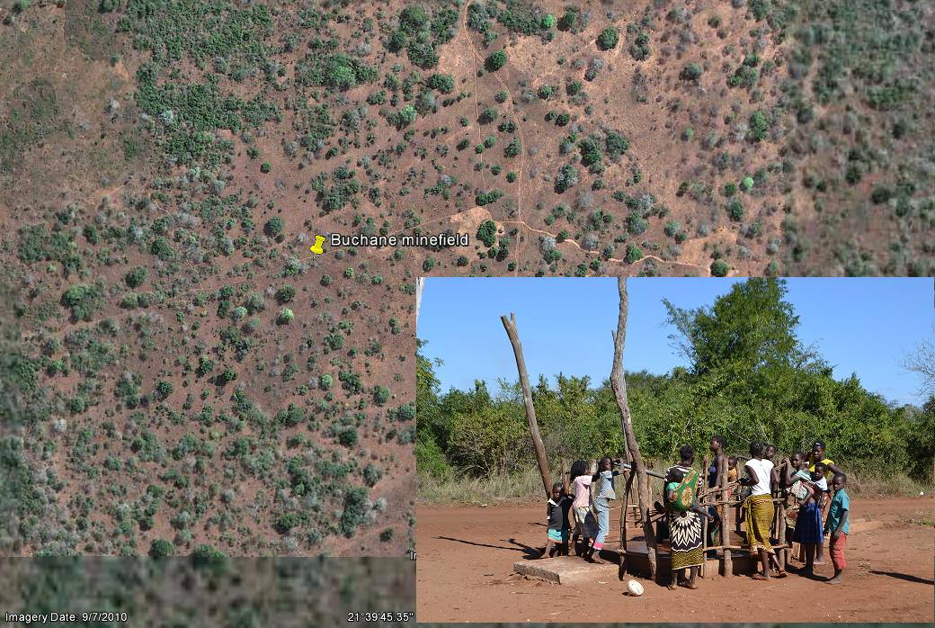
BUCHANE Minefield
BUCHANE water pump
Photo 3: Buchane students using the water pump in the vicinity of the Buchane minefield, Inhassoro District, cleared by HI Demining Teams in 2014

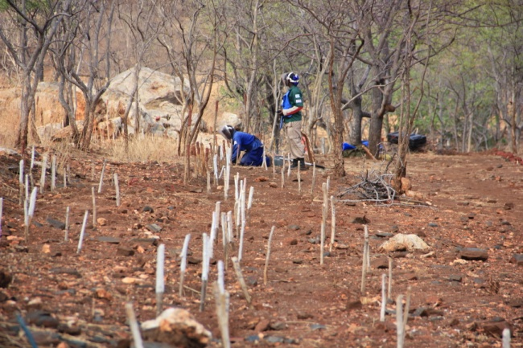
Photo 4: Halo Trust teams working in 2014 on the border minefield at N’Soluwamuthu in Tete Province. Each white stick identifies an anti-personnel landmine found and destroyed.

Summary Conclusion for Output 2:
In total, the humanitarian mine action activities financially supported by the Government of Sweden contributed to the clearance and release of 93 suspected or confirmed hazard areas (aka demining tasks) including 266 electrical pylons along the Beira I and Beira II power lines. The work in these area resulted in the total release and clearance of 6,496,965 square meters of previously landmine suspected area back to productive use by the local population. These demining operations also resulted in the removal and destruction of 21,918 anti-personnel landmines, 4 anti-vehicle mines and 396 items of unexploded ordnance.

Summary of Swedish Contribution to Demining Results achieved in 2013-2014:
Operator | Demining Tasks | Electricity Pylons | Square meters of land cleared and released | Items found & destroyed
 |  |  |  | APM | AVM | UXO
APOPO | 24 | 52 | 2,582,670 | 26 | 0 | 13
HT | 4 | 0 | 442,680 | 17,559 | 0 | 0
HI | 61 | 214 | 3,313,289 | 3,621 | 0 | 383
NPA | 4 | 0 | 158,326 | 712 | 4 | 0
Totals: | 93 | 266 | 6,496,965 | 21,918 | 4 | 396

The support provided by the government of Sweden also enabled the Government to monitor the demining operations in the field and conduct a total of 508 quality assurance activities during the reporting period. This work enabled the government to declare an additional 19 districts as ‘mine-free’ or free of all known mined areas. The total number of mine-free districts increased from 105 districts at the start of the project in 2013 to 124 districts at the end of 2014 out of a total of 128 districts in Mozambique. While Mozambique fell short of its goal of classifying all 128 Districts as free of all known mined areas by the end of 2014, IND continues to work and hopes to classify the remaining 4 districts in Sofala and Manica as mine free in 2015.

Despite the tremendous progress achieved during the project period, Mozambique still faced several challenges to complete demining by the deadline established by the APMBC. During the project period, the IND and the GoM, as part of its regular evaluation of mine action progress, determined that Mozambique needed an additional 10-months to complete their obligations to clear all known mined areas in accordance with Article 5 of the Mine Ban Convention. In 2013, the Government of Mozambique therefore submitted and was granted a request to extend Mozambique’s demining deadline to comply with article 5 of the Mine Ban Convention until December 2014.

Thanks to the support of a number of partners, Mozambique came extremely close to completing implementation by its 31 December 2014 deadline. Despite the best efforts of the National Mine Action Programme, Mozambique was unfortunately unable to complete the demining of all known mined areas by the December 2014 Deadlines. The National Demining Institute and Humanitarian Demining operators cited the following reasons, why demining operations were not possible to conclude within the 2014 deadline:
- Military hostilities in the central region created a situation of temporary insecurity that persisted between January and August 2014 in the provinces of Manica and Sofala. This prevented access to some mined areas in these provinces and created transportation and logistical difficulties to access the demining tasks.
- Higher transport and logistical costs were incurred due to the continuing insecurity and productivity in the affected areas was reduced. For example, due to conflict in Southern Sofala, teams and equipment from the south had to travel an alternative route via Zimbabwe which delayed deployment and increased costs.
- Heavy rains in December 2014, led to the suspension of some demining tasks in Manica and Sofala Provinces that otherwise would have been completed by the 31 December 2014 deadline.

Mozambique has worked hard to comply with its deadline. Having slightly missed it, however, Mozambique is committed to being highly transparent with regard to the challenges that remain and the plan to overcome them. With the continued support of its international partners, the IND is confident the remaining mine suspected areas can be completed within 2015.

Output 3: Establishment of a national mechanism to address residual risks from ERW
UNDP originally planned to support the establishment of a national mechanism to address residual UXO and ERW threats through capacity assessments of various government institutions, training and procurement of equipment. However, during the initial project period of 2013, UNDP was not able to identify suitable consultants for the capacity assessments and planned to re-launch the tender for consultants. Furthermore, the GoM’s extension of the demining deadline until December 2014 led to the postponement of the training and equipping for police in Explosive Ordnance Disposal (EOD) in mine-free provinces.

In 2014, IND and UNDP partnered with the GICHD to produce a capacity assessment of Mozambique’s National Capacities to Manage Residual Contamination from Explosive Remnants of War after the end of demining. This partnership reduced the cost of expenditures for these activities. The capacity assessment was completed in 2014 and used by UNDP, IND and GICHD to draft a proposed strategy for Mozambique to manage the residual contamination from explosive remnants of war. IND intends to use the capacity assessment and draft strategy in 2015 to advise the government on a transition to a national mechanism to manage residual ERW contamination after the completion of demining and the establishment of a training centre in Mozambique to manage residual ERW contamination.

However, due to the reduced costs and the delay in the activities under this Output, the UNDP was unable to utilize the allocated funding within the original project period 2013-2014.

The results and status of the activities under this output are summarized in the table below:

Results Summary Table for Output 3
Project Output and Activity | Planned Activity and Indicator | Results | Remarks
Output 3: Facilitate the establishment of a national mechanism to address residual risks from ERW | Project Activity 3.1: Facilitate the government’s approach to develop a sustainable national capacity to deal with residual explosive remnants of war by training and equipping the police for explosive ordinance disposal in provinces where demining is completed. | In 2014, UNDP and GICHD partnered to produce a capacity assessment of MOZ institutes and a draft strategy for the management of ERW. This partnership reduced the cost of expenditures for these activities. In addition, the government’s extension of the demining deadline until December 2014 led to the postponement of the training and equipping for police in EOD in mine-free provinces. The EOD training and equipping of Police in Gaza Province was completed in Nov 2014. Additional trainings for Maputo and Inhambane Provinces are to be conducted in 2015. UNDP is requesting a no-cost extension for this activity to conduct the training and equipping of police in 2015. | Partially achieved;  Training postponed until 2015.

5.1 Gender Activities

Throughout the project period, gender issues were mainstreamed into ongoing mine action activities. Gender roles and the differing impacts of landmines on men, women, boys and girls were taken into account in specific mine action activities including surveys, clearance, land release, quality assurance and in the handover of released land. Mine risk education (MRE) information materials produced under the mine action programme targets all segments of the community including girls, boys, men and women.

Landmine contamination can have greater or lesser impacts on men, women, boys and girls depending on the various gender roles applied by society. In accordance with the National Mine Action Standards, wherever possible sex disaggregated data is collected and women and children are included in all survey activities as well as other demining activities.

At the end of 2014, UNDP and IND also assisted a mission of the Gender Mine Action Project (GMAP) to Mozambique. During the mission, the GMAP consultant held training for IND and the demining operators on mainstreaming gender into mine action. The GMAP consultant also conducted an assessment of how gender was integrated into mine action in Mozambique and provided a report with recommendations for improvements. These recommendations were reviewed and will be integrated into mine action activities implemented by IND and the demining operators in 2015.

The project also promotes the equal opportunity recruitment for staff of the projects and all contractors. The UNDP and IND continued to advocate for equal employment opportunities for women in the demining sector. As a result, operators paid closer attention to the issue of gender balance in their teams. Due to the working conditions of demining operations, it is not always easy for female deminers to balance work and life, thus making it more difficult to recruit female deminers. However, good progress was achieved in 2012 in this area when Handicap International, APOPO and Norwegian People’s Aid all hired and trained additional women who are deployed and mixed in teams involved in various tasks including manual and mechanical demining. By the end March 2013, all four Humanitarian demining operators in Mozambique employed all female or mixed gender demining and survey teams.

6.0 Challenges, Responses and Lessons Learned

- In order to achieve the goal of clearing all known mine suspected areas by the end of 2014, additional financial resources were required. A well-coordinated and close partnership among IND, UNDP and the donor partners led to increases in mine action funding in Mozambique between 2012 and 2013. This sustained, coordinated approach to resource mobilization ensured that that the 2014 funding gap was closed and all sufficient financial support was provided to humanitarian demining efforts in 2014.
- New mine suspected areas continued to be found during Mine Free District Assessments in 2012 and 2013 adding to the total amount of mine suspected areas that need to be surveyed and/or cleared before the end of 2014. Due to this challenge, two strategies were implemented to increase the efficiency of mine action in Mozambique. The first is to increase the use of mechanical demining assets in Mozambique. The second strategy is to increase the use of land release procedures in accordance with the revised National Mine Action Standards on Mine Action in Mozambique.
- Extensive minefields along the Mozambique-Zimbabwe border remained to be cleared in 2014. A political agreement between the two States would facilitate the demining at the border since most of these minefields straddle both sides of the border and some minefields in Mozambique are best accessed from the Zimbabwe side of the border. The IND and Zimbabwe Mine Action Centre met several times in an attempt to develop a joint plan for demining the border. In the end, a joint plan to demine the border proved not to be necessary to ensure clearance of all known areas on the Mozambican side of the border. However, a cross-border agreement would have reduced costs and risks for Mozambican mine action activities along the border. Mozambique did everything in its power to conclude the political agreement with Zimbabwe in order to facilitate the safe demining of the border at the minimum possible costs, but unfortunately the two-parties could not conclude an agreement within the project period. Demining on the Zimbabwe side of the border will continue for several years to come. A bilateral agreement between the two countries could still be useful to facilitate the sharing of information, exchange of mine action resources and experience. Unfortunately, as long as landmines remain on the Zimbabwe border, Mozambican citizens will continue to be victims of landmines, even though no known mined areas remain on Mozambican territory.
- Despite the best efforts of the National Mine Action Programme, Mozambique was unfortunately unable to complete the demining of all known mined areas by the December 2014 deadline. Having missed the December 2014 deadline, Mozambique is committed to being highly transparent with regard to the challenges that remain and Mozambique’s plan to overcome them as soon as possible. All remaining demining tasks are well known and the National Demining Institute has developed a plan with the Humanitarian Demining Operators to complete them as soon as possible and declare the remaining districts as free of all known mined areas within 2015. As of 28 January 2015, a total of 56 tasks covering 289,660 square meters remain to be surveyed and cleared in the Provinces of Manica, Sofala and Inhambane. As of January 2015, the demining capacity in Mozambique has been reduced because there are currently not sufficient tasks for all deminers. The IND and the UNDP estimate that sufficient financial resources exist to complete the remaining work in 2015 should Mozambique receive no-cost extensions from existing donors. In this regard, the UNDP Mine Action Project kindly requests a no-cost extension from the Government of Sweden to utilize the remaining balance of unspent funds from the Swedish contribution to support mine clearance activities in 2015.

Annexes:
      - Certified Financial Report 2013
      - Detailed Financial Report 2013-2014
      - Provisional Financial Statement Report 2013-2014
      - Audit Reports and Risk Assessments for 2013 and 2014

In March 2013, the Government of Mozambique revised the district boundaries and created an additional 13 new districts for a total of 141 districts in Mozambique. In order to avoid confusion, the IND is continuing to use the boundaries of the larger 128 districts as originally included in the 2008-2014 National Mine Action Plan.
In March 2013, the Government of Mozambique revised the district boundaries and created an additional 13 new districts for a total of 141 districts in Mozambique. In order to avoid confusion, the IND is continuing to use the boundaries of the larger 128 districts as originally included in the 2008-2014 National Mine Action Plan.
Audits of 2014 accounts of implementing partners are being conducted in March and April 2015. Final Audit reports covering 2014 accounts will be submitted to the Embassy of Sweden in May 2015.

